MACH4METAL

metalworking machinery
Transito 21,
6909 DA BABBERICH, Netherlands
Tel. + 31 (0)316 – 247123
Fax. + 31 (0)316 - 247956
info@mach4metal.com
www.mach4metal.com

Bank No : 66.52.13.883
IBAN : NL33 INGB 0665 2138 83
BIC : INGBNL2A

Turning lathe VDF DUE 710 x 2000

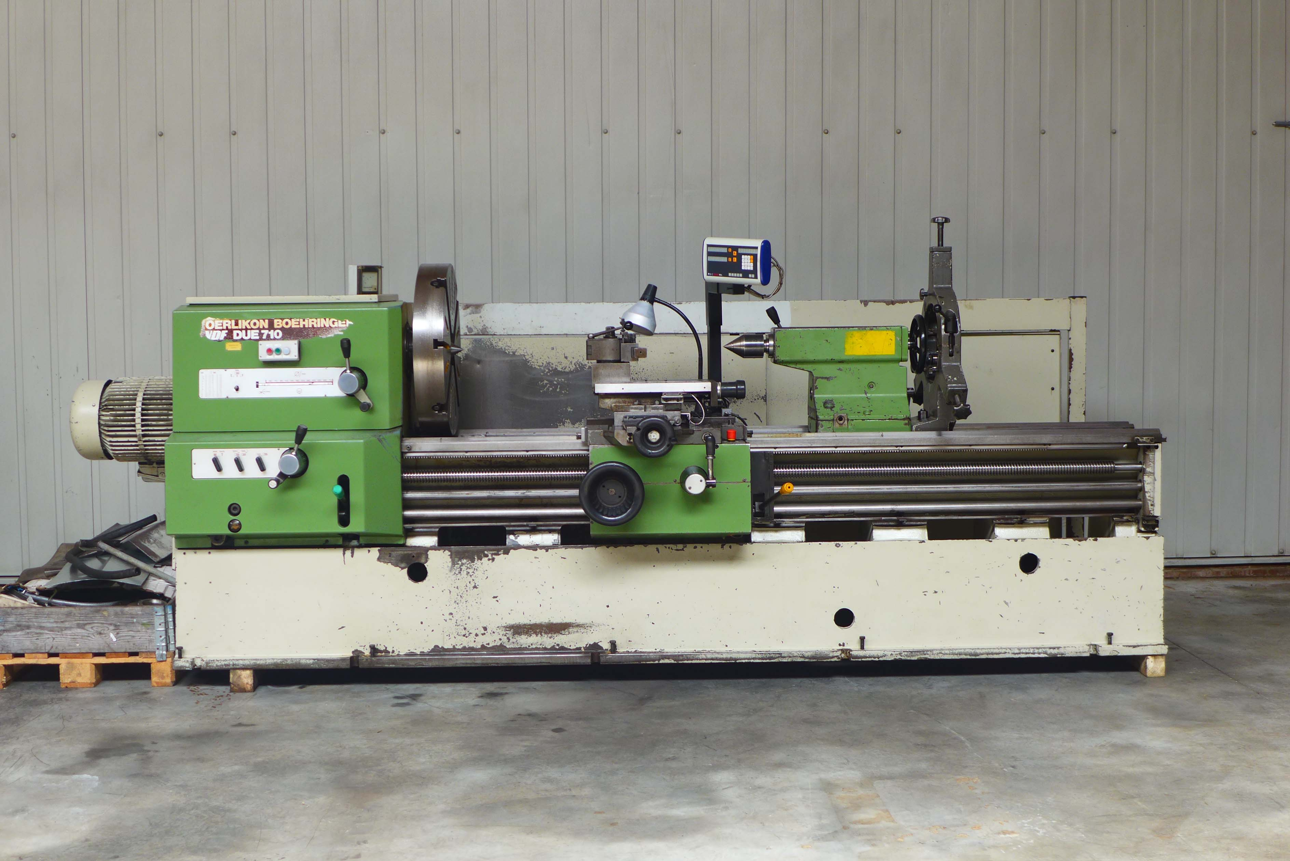
- Make : VDF Boehringer Germany
- Typ : DUE 710
- Age : 1982
- Mach.No : 103 210 - 1708

- Swing over bed : 750
- Swing over cross slide : 450
- Spindle hole : 82/120
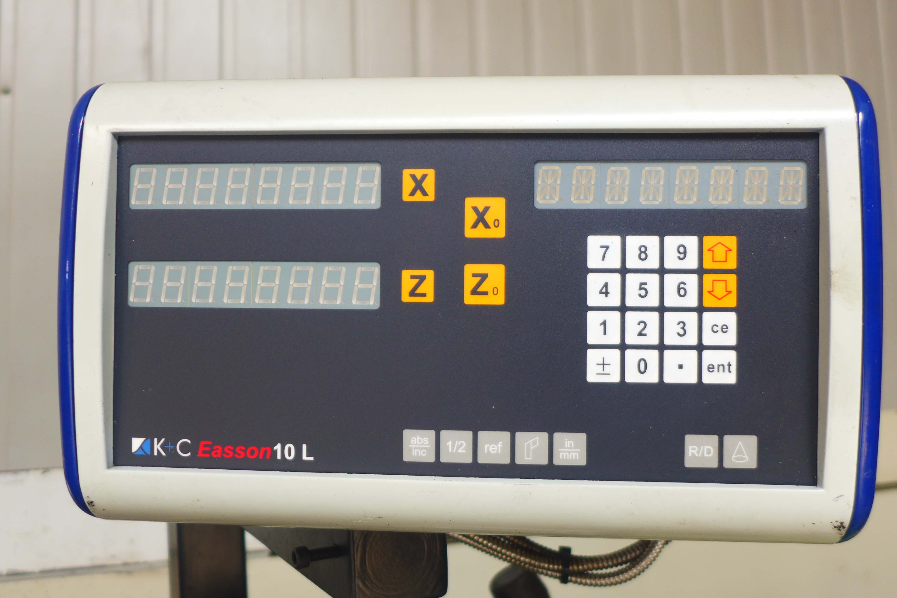
- Turning length : 2.000
- Bed width : 450

- Speeds 24 steps : 9 - 1800 R/pm
- Feeds : 0,063 – 56 mm

- Feeds in 3 directions
- 4 chuck Ø 710
- Digital readout K & C
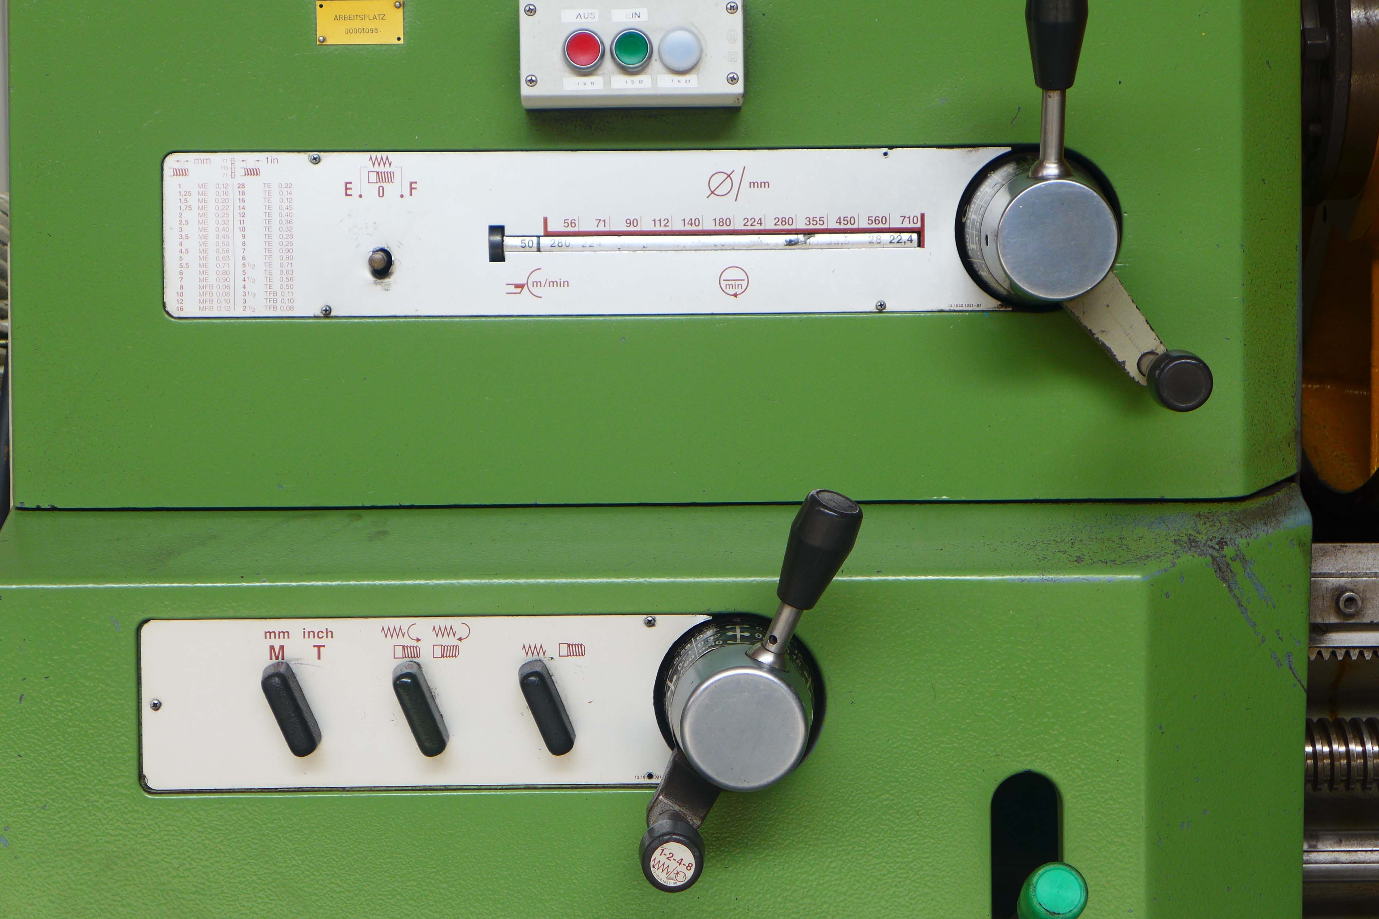
- Multi fix tool system
- Dimensions
- Length : 5.000
- Width : 1.900
- Height : 2.000
- Weight : 6.900
- Power : 400 V / 22 kW

Please Note: The above information has been obtained to the best of our ability and belief from, and from the manufacturers where possible. It is given in good faith, but its accuracy can not be guaranteed. Accordingly, it will not form a representation or constitute contractual terms. We advise you to check any vital details



